**Lab 18: Android Internal Storage**

# **Introduction**

Internal storage is the storage of the private data on the device memory. By default these files are private and are accessed by only your application and get deleted , when user delete your application.

# **Write into File (FileOutputStream)**

# **Read from File (FileInputStream)**

**Let’s get Started:**

**Step 1: Create a New Project in Android Studio as shown below**

**Step 2: Select Empty Activity as shown below**

**Step 3: Provide a Project Name as shown below**

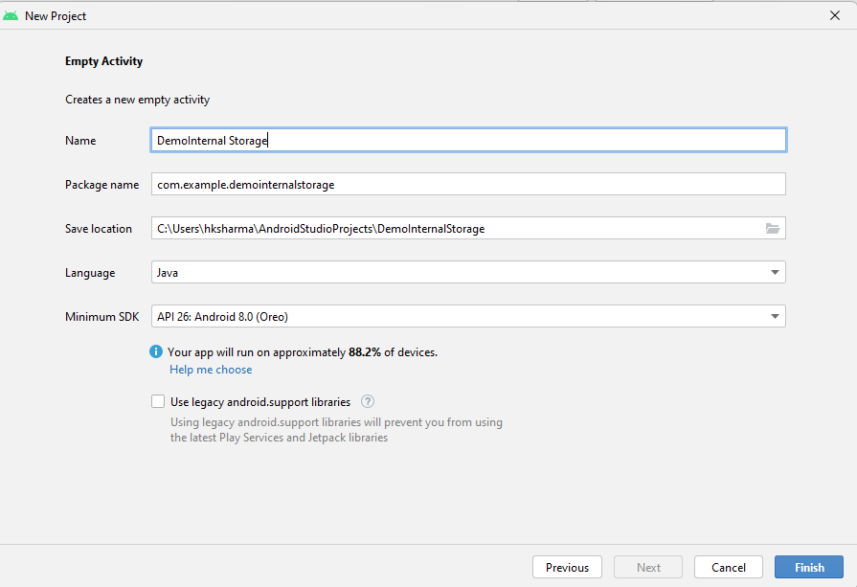

**Step 4: Update MainActivity.java as per the code given below**

**package** com.example.demointernalstorage2;  
**import** android.content.Context;  
**import** android.os.Bundle;  
**import** android.view.View;  
**import** android.widget.Button;  
**import** android.widget.EditText;  
**import** android.widget.Toast;  
**import** androidx.appcompat.app.AppCompatActivity;  
**import** java.io.BufferedReader;  
**import** java.io.FileNotFoundException;  
**import** java.io.FileOutputStream;  
**import** java.io.IOException;  
**import** java.io.InputStreamReader;  
  
**public class** MainActivity **extends** AppCompatActivity {  
 EditText **editTextFileName**,**editTextData**;  
 Button **saveButton**,**readButton**;  
 @Override  
 **protected void** onCreate(Bundle savedInstanceState) {  
 **super**.onCreate(savedInstanceState);  
 setContentView(R.layout.***activity_main***);  
  
 **editTextFileName**=findViewById(R.id.***editText1***);  
 **editTextData**=findViewById(R.id.***editText2***);  
 **saveButton**=findViewById(R.id.***button1***);  
 **readButton**=findViewById(R.id.***button2***);  
  
 *//Performing Action on Read Button* **saveButton**.setOnClickListener(**new** View.OnClickListener(){  
  
 @Override  
 **public void** onClick(View arg0) {  
 String filename=**editTextFileName**.getText().toString();  
 String data=**editTextData**.getText().toString();  
  
 FileOutputStream fos;  
 **try** {  
 fos = openFileOutput(filename, Context.***MODE_PRIVATE***);  
 *//default mode is PRIVATE, can be APPEND etc.* fos.write(data.getBytes());  
 fos.close();  
  
 Toast.*makeText*(getApplicationContext(),filename + **" saved"**,  
 Toast.***LENGTH_LONG***).show();  
  
  
 } **catch** (FileNotFoundException e) {e.printStackTrace();}  
 **catch** (IOException e) {e.printStackTrace();}  
  
 }  
  
 });  
  
 *//Performing Action on Read Button* **readButton**.setOnClickListener(**new** View.OnClickListener(){  
  
 @Override  
 **public void** onClick(View arg0) {  
 String filename=**editTextFileName**.getText().toString();  
 StringBuffer stringBuffer = **new** StringBuffer();  
 **try** {  
 *//Attaching BufferedReader to the FileInputStream by the help of InputStreamReader* BufferedReader inputReader = **new** BufferedReader(**new** InputStreamReader(  
 openFileInput(filename)));  
 String inputString;  
 *//Reading data line by line and storing it into the stringbuffer* **while** ((inputString = inputReader.readLine()) != **null**) {  
 stringBuffer.append(inputString + **"\n"**);  
 }  
  
 } **catch** (IOException e) {  
 e.printStackTrace();  
 }  
 *//Displaying data on the toast* Toast.*makeText*(getApplicationContext(),stringBuffer.toString(),Toast.***LENGTH_LONG***).show();  
  
 }  
  
 });  
 }  
}

**Step 5: Update activity_main.xml for Relative Layout as per the code given below**

*<?***xml version="1.0" encoding="utf-8"***?>*<**LinearLayout xmlns:android="http://schemas.android.com/apk/res/android"  
 xmlns:tools="http://schemas.android.com/tools"  
 android:layout_width="match_parent"  
 android:layout_height="match_parent"  
 android:orientation="vertical"  
 android:gravity="center"  
 tools:context=".MainActivity"** >  
  
 <**TextView  
 android:layout_width="wrap_content"  
 android:layout_height="wrap_content"  
 android:text="Internal Storage Example"  
 android:layout_centerHorizontal="true"  
 android:textSize="30dp"** />  
  
 <**EditText  
 android:id="@+id/editText1"  
 android:layout_width="wrap_content"  
 android:layout_height="wrap_content"  
 android:hint="Enter a File Name "  
 android:layout_marginTop="24dp"  
 android:ems="10"** >  
 <**requestFocus** />  
 </**EditText**>  
  
 <**EditText  
 android:id="@+id/editText2"  
 android:layout_width="wrap_content"  
 android:layout_height="wrap_content"  
 android:layout_marginTop="24dp"  
 android:hint="Enter Data to Store"  
 android:ems="10"** />  
  
 <**Button  
 android:id="@+id/button1"  
 android:layout_width="wrap_content"  
 android:layout_height="wrap_content"  
 android:text="Write Data"** />  
  
 <**Button  
 android:id="@+id/button2"  
 android:layout_width="wrap_content"  
 android:layout_height="wrap_content"  
  
 android:text="Read Data"** />  
  
</**LinearLayout**>

**Step 6: Check Output on Android Emulator and it should look like as given below**

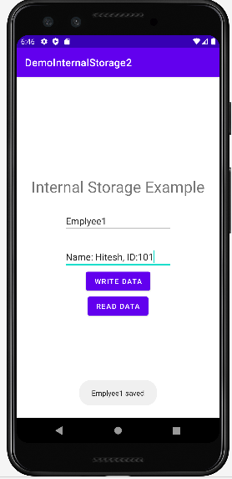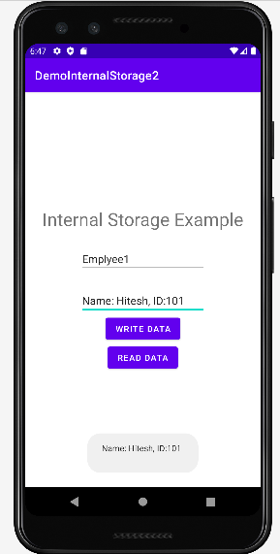

**Voila!!** We have successfully completed this lab.